# Project Summary – Employee Attrition Analysis using HR Data

**Steps Followed**

Data Preparation (Google Colab)

Import Dataset: Loaded the Cleaned_HR_Data_Analysis.csv file into Colab.

Data Cleaning: Dropped irrelevant columns (like EmployeeID).

Checked for missing values and duplicates.

Encoded categorical variables (e.g., Gender, Department) into numeric form using Label Encoding.

Feature Selection: Defined features (X) such as Age, PayZone, EngagementScore, etc., and set Attrition as the target (y).

Train/Test Split: Split the dataset into training (70%) and testing (30%) subsets.

Model Training: Built a Decision Tree Classifier to predict attrition.

Model Evaluation:

Measured accuracy, precision, recall, and F1-score.

Generated a confusion matrix for classification performance.

**Visualization & Insights (Power BI)**

Imported the processed dataset (Processed_HR_Data.csv) into Power BI.

Built dashboards to visualize attrition patterns across PayZone, Engagement Score, and Gender.

Extracted insights to link key factors with attrition behaviour.

**Key Insights**

Attrition by PayZone (Pie Chart)

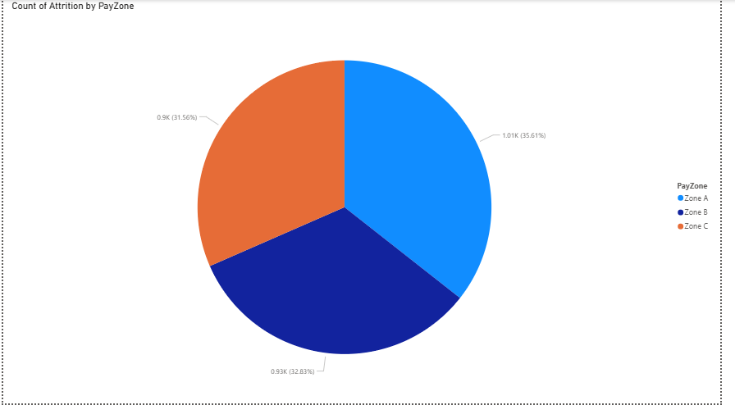

Zone A has the highest attrition count (~35.6%).

Zone C and Zone B follow closely with ~32.8% and ~31.6% respectively.

**Insight**: Attrition is fairly distributed but slightly higher in Zone A.

Engagement Score by Attrition (Bar Chart)

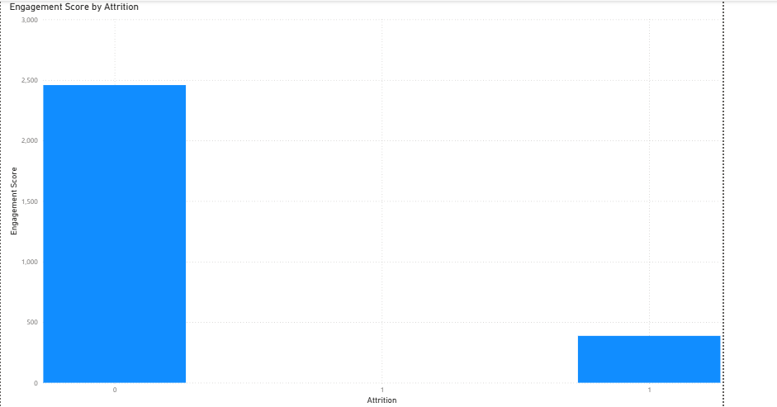

Employees who stayed (Attrition = 0) show a much higher engagement score (~2,500).

Employees who left (Attrition = 1) show a very low engagement score (<400).

**Insight**: Engagement score is a strong predictor of attrition.

Attrition by Gender (Bar Chart)

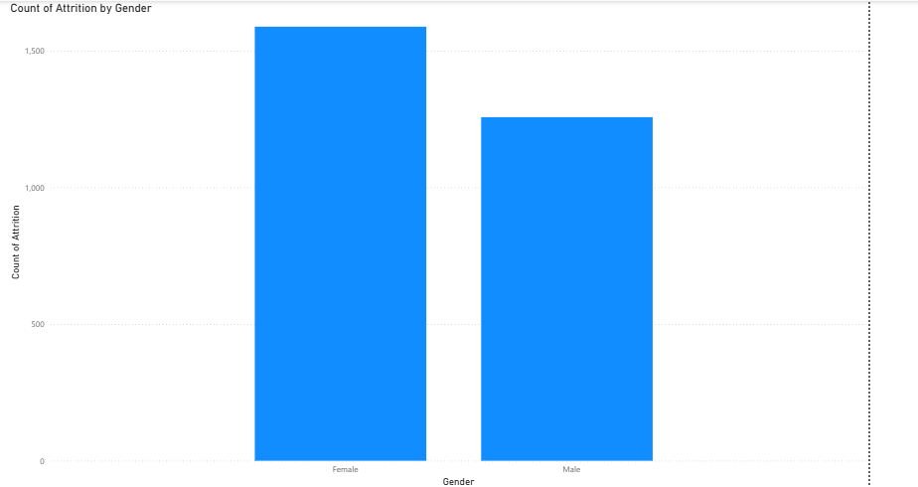

Female employees: higher attrition (~1,600).

Male employees: lower attrition (~1,300).

Insight: Female employees are leaving at higher rates than males.

# Conclusion

The Decision Tree model made helps identify employees likely to leave based on engagement, pay zone, and demographics.

Low engagement score is the strongest signal of attrition.

Zone A and female employees show slightly higher risk (i.e.; Employees who have a lower work life balance score and a lower rating and engagement score, they tend to leave on their own).

These findings can guide HR strategies like targeted engagement programs, tailored retention policies, and pay structure reviews.